LAMP+DNS+NFS搭建discuz论坛

两台web服务器，共享关系型数据库，共享NFS服务器，利用DNS记录轮询提供负载均衡；

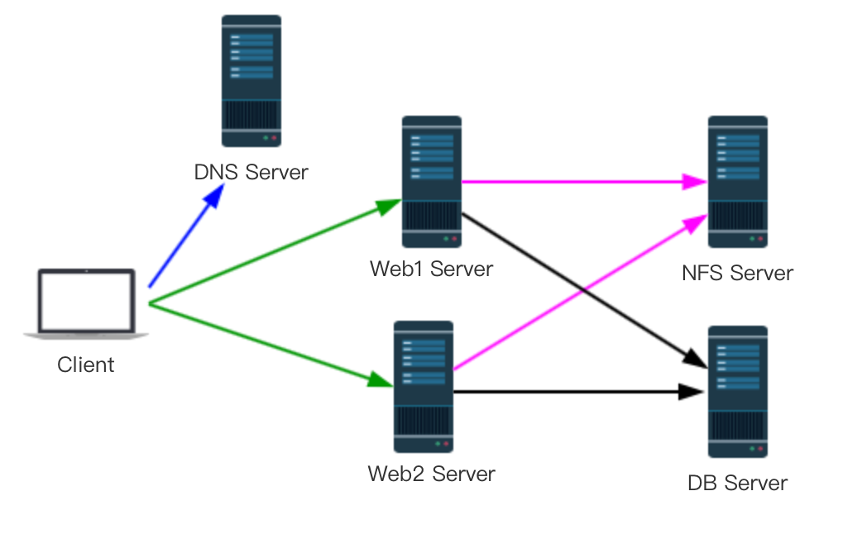

实现的功能：

0、两台Web服务作为客户端访问论坛的前端；

1、能够使用DNS自动轮训的方式实现两天Web服务器访问的负载均衡；

|  |  |  |
| --- | --- | --- |
|  | 主机名 | IP地址 |
| DNS Server | [dns.discuz.com](http://dns.discuz.com) | 172.16.227.130 |
| DFS Server | [dfs.discuz.com](http://dfs.discuz.com) | 172.16.227.154 |
| Web1 Server | [web1.discuz.com](http://web1.discuz.com) | 172.16.227.156 |
| Web 2 Server | [web2.discuz.com](http://web2.discuz.com) | 172.16.227.153 |
| DB Server | [db.discuz.com](http://db.discuz.com) | 172.16.227.166 |
| Client | Client | 172.16.227.1 |

2、使用NFS Server的共享存储作为论坛的安装路径，以存放论坛的一些非结构化数据，（例如：图片，文字，可下载的文件，等等）；

3、使用DB Server实现结构化数据的存储，（例如：用户名、密码，等等）；

规划：

1、主机名及ip地址

2、搭建DNS服务器，添加两条A记录

www IN A 172.16.227.156

www IN A 172.16.227.153

3、搭建NFS服务器，提供共享文件系统

# vim /etc/exports

/share/nfs 172.16.227.1156(rw) 172.16.227.153(rw)

# exportfs -ar

4、搭建web1

编译安装httpd-2.4.25,php-5.4.40

5、搭建web2

编译安装httpd-2.4.25,php-5.4.40

6、搭建DB

通用二进制格式安装mariaDB-5.5.43

7、安装discuz

在NFS虚拟机上，将安装包解压至/share/nfs

# cp -a ./uoload/* /share/nfs

         # chmod -R o+rw ./config

         # chmod -R o+rw ./data

         # chmod -R o+rw ./un_server

         # chmod -R o+rw ./un_client

8、测试

将Client的DNS修改为172.16.227.130，进行测试。

# vim /etc/resolv.conf

nameserver 172.16.227.130

实现：

1、搭建DNS服务器

（1）安装DNS

# yum install bind -y

（2）配置DNS

a、修改主配置文件，使其监听172.16.227.130

~]# vim /etc/named.conf

listen-on port 53 { 172.16.227.130; };

allow-query { any; };

b、修改次配置文件，添加[discuz.com](http://discuz.com) 正向解析区域

~]# vim /etc/named.rfc1912.zones

zone "discuz.com" IN {

type master;

file "discuz.com";

allow-update { none; };

};

c、创建[discuz.com](http://discuz.com)正向解析区域文件

~]# vim /var/named/discuz.com.zone

$TTL 3600

$ORIGIN discuz.com.

@ SOA dns.discuz.com. dnsadmin.discuz.com. ( 2017051801 2H 10M 3D 1D)

@ IN NS dns.discuz.com.

dns IN A 172.16.227.130

www IN A 172.16.227.156

www IN A 172.16.227.153

blog IN CNAME [www.discuz.com](http://www.discuz.com).

d、检测dns配置文件

~]# named-checkconf

~]# named-checkzone "discuz.com" /var/named/discuz.com.zone

zone discuz.com/IN: loaded serial 2017051801

OK

e、启动named服务

~]# service named start

Starting named: named: already running [ OK ]

f、测试

Client$ dig -t A www.discuz.com @172.16.227.130

; <<>> DiG 9.8.3-P1 <<>> -t A www.discuz.com @172.16.227.130

;; global options: +cmd

;; Got answer:

;; ->>HEADER<<- opcode: QUERY, status: NOERROR, id: 49589

;; flags: qr aa rd ra; QUERY: 1, ANSWER: 2, AUTHORITY: 1, ADDITIONAL: 1

;; QUESTION SECTION:

;www.discuz.com. IN A

;; ANSWER SECTION:

www.discuz.com. 3600 IN A 172.16.227.153

www.discuz.com. 3600 IN A 172.16.227.156

;; AUTHORITY SECTION:

discuz.com. 3600 IN NS dns.discuz.com.

;; ADDITIONAL SECTION:

dns.discuz.com. 3600 IN A 172.16.227.130

;; Query time: 0 msec

;; SERVER: 172.16.227.130#53(172.16.227.130)

;; WHEN: Thu May 18 16:08:23 2017

;; MSG SIZE rcvd: 98

Client$ dig -t A www.discuz.com @172.16.227.130

; <<>> DiG 9.8.3-P1 <<>> -t A www.discuz.com @172.16.227.130

;; global options: +cmd

;; Got answer:

;; ->>HEADER<<- opcode: QUERY, status: NOERROR, id: 65243

;; flags: qr aa rd ra; QUERY: 1, ANSWER: 2, AUTHORITY: 1, ADDITIONAL: 1

;; QUESTION SECTION:

;www.discuz.com. IN A

;; ANSWER SECTION:

www.discuz.com. 3600 IN A 172.16.227.156

www.discuz.com. 3600 IN A 172.16.227.153 <—注意两次查询的顺序不一样。

;; AUTHORITY SECTION:

discuz.com. 3600 IN NS dns.discuz.com.

;; ADDITIONAL SECTION:

dns.discuz.com. 3600 IN A 172.16.227.130

;; Query time: 0 msec

;; SERVER: 172.16.227.130#53(172.16.227.130)

;; WHEN: Thu May 18 16:09:37 2017

;; MSG SIZE rcvd: 98

2、搭建NFS服务器，提供NFS文件系统

因为centos6使用的内核中自带NFS模块，所以直接启用就可以了

  如果没有则需要安装

~]# yum install nfs-utils

      ~]# service nfs start

      ~]# rpcinfo -p          //查看nfs服务是不是开启成功

~]# mkdir /share/nfs

      ~]# vim /etc/exports    //添加需要共享的挂载点，设置规则可读写

/share/nfs 172.16.227.153(rw) 172.16.227.156(rw)

~]# exportfs -ra //重新导出所有的文件系统

~]# showmount -e 172.16.227.154 //查看172.16.227.154上共享的挂载点

Export list for 172.16.227.154:

/share/nfs 172.16.227.156,172.16.227.153

将NFS文件系统挂载至web服务器

~]# mkdir /web/blog -pv

~]# mount -t nfs 172.16.227.154:/share/nfs /web/blog

3、搭建web server 安装httpd及http

参考配置文档：编译安装httpd-2.4.25 及 模块式安装php-5.4.40及xcache

4、搭建DB服务器

参考配置文档：通用二进制格式安装MariaDB-5.5.40

安装完成后创建数据库及远程登录用户

# mysql

> CREATE DATABASE IF NOT EXISTS discuz_db CHARACTER SET = 'utf8';

Query OK, 1 row affected (0.00 sec)

> GRANT ALL ON discuz_db.* TO 'discuz'@'172.16.227.%' IDENTIFIED BY 'discuzpass';

Query OK, 0 rows affected (0.00 sec)

> FLUSH PRIVILEGES;

Query OK, 0 rows affected (0.00 sec)

> SELECT host,user,password FROM user WHERE user='discuz';

+--------------+--------+-------------------------------------------+

| host | user | password |

+--------------+--------+-------------------------------------------+

| 172.16.227.% | discuz | *DDB4A899AABD3D61F64BDF57423CCB9B34ABFD83 |

+--------------+--------+-------------------------------------------+

1 row in set (0.00 sec)

5、测试php+mysql

# vim /usr/local/apache/htdocs/index.php

<html><body><h1>It works!</h1></body></html>

<?php

$link = mysql_connect('172.16.227.180','discuz','discuzpass');

if ($link)

echo "Success...";

else

echo "Failure...";

mysql_close();

phpinfo();

?>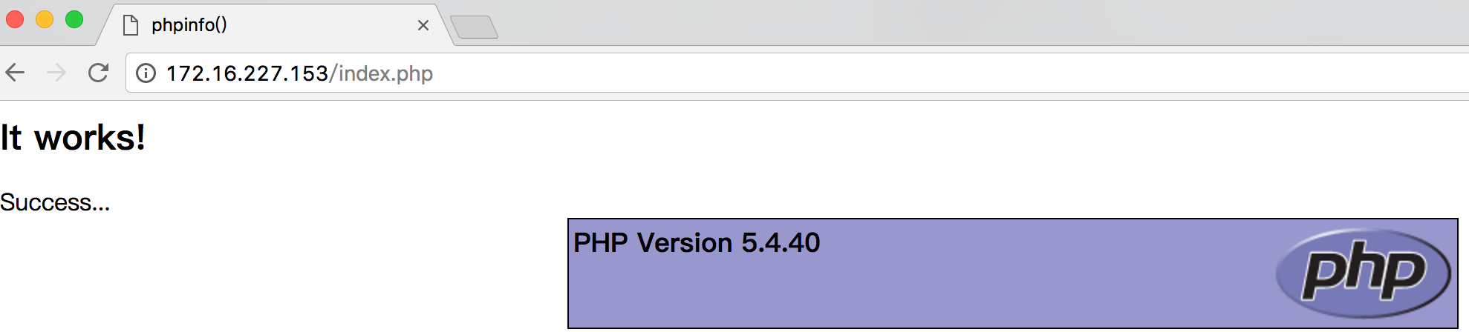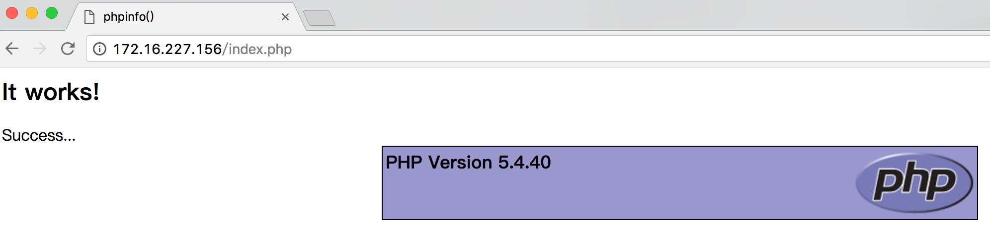

6、安装discuz（172.16.227.154）

（1）下载Discuz_X3.2_SC_UTF8.zip

src]# wget <http://download.comsenz.com/DiscuzX/3.2/Discuz_X3.2_SC_UTF8.zip>

（2）解压

src]# unzip Discuz_X3.2_SC_UTF8.zip

（3）复制相关文件至nfs文件系统内

src]# cp -a upload/* /share/nfs/

（4）准备配置文件

src]# cd /share/nfs/

nfs]# cp config/config_global_default.php config/config_global.php

nfs]# cp config/config_ucenter_default.php config/config_ucenter.php

修改相关权限，后面安装Discuz会用到，不过这样改感觉很不安全啊。

nfs]# chmod -R o+rw config/

nfs]# chmod -R o+rw data/

nfs]# chmod -R o+rw uc_client/

nfs]# chmod -R o+rw uc_server/

8、配置web Server相关设置

~]# vim /etc/httpd/httpd.conf

DocumentRoot "/web/blog"

<Directory “/web/blog">

重新加载

~]# service httpd reload

9、分别测试两台web Server是否能够提供Discuz安装业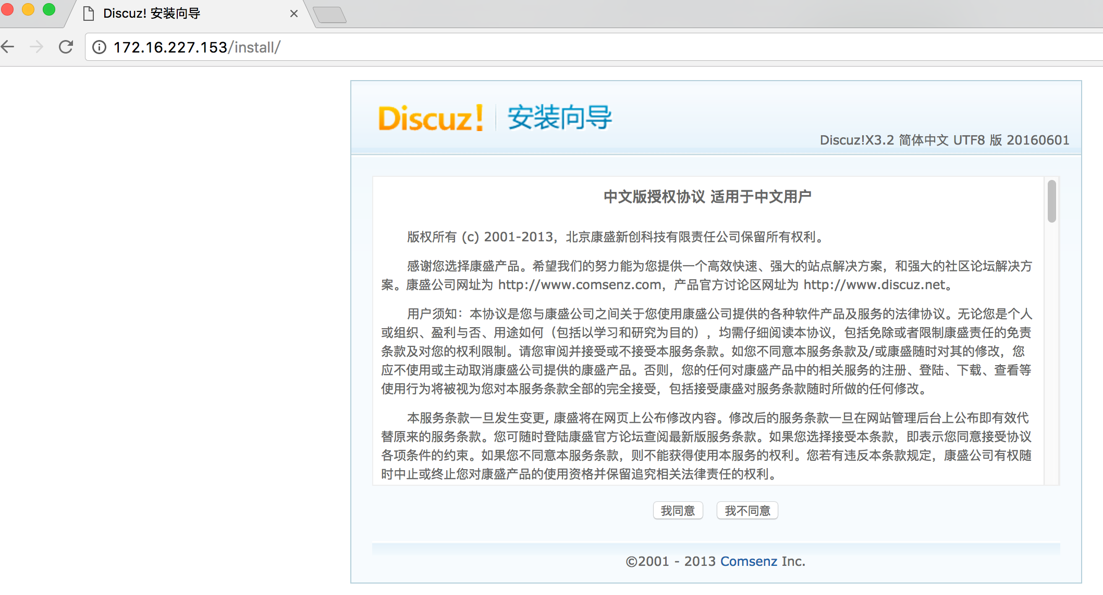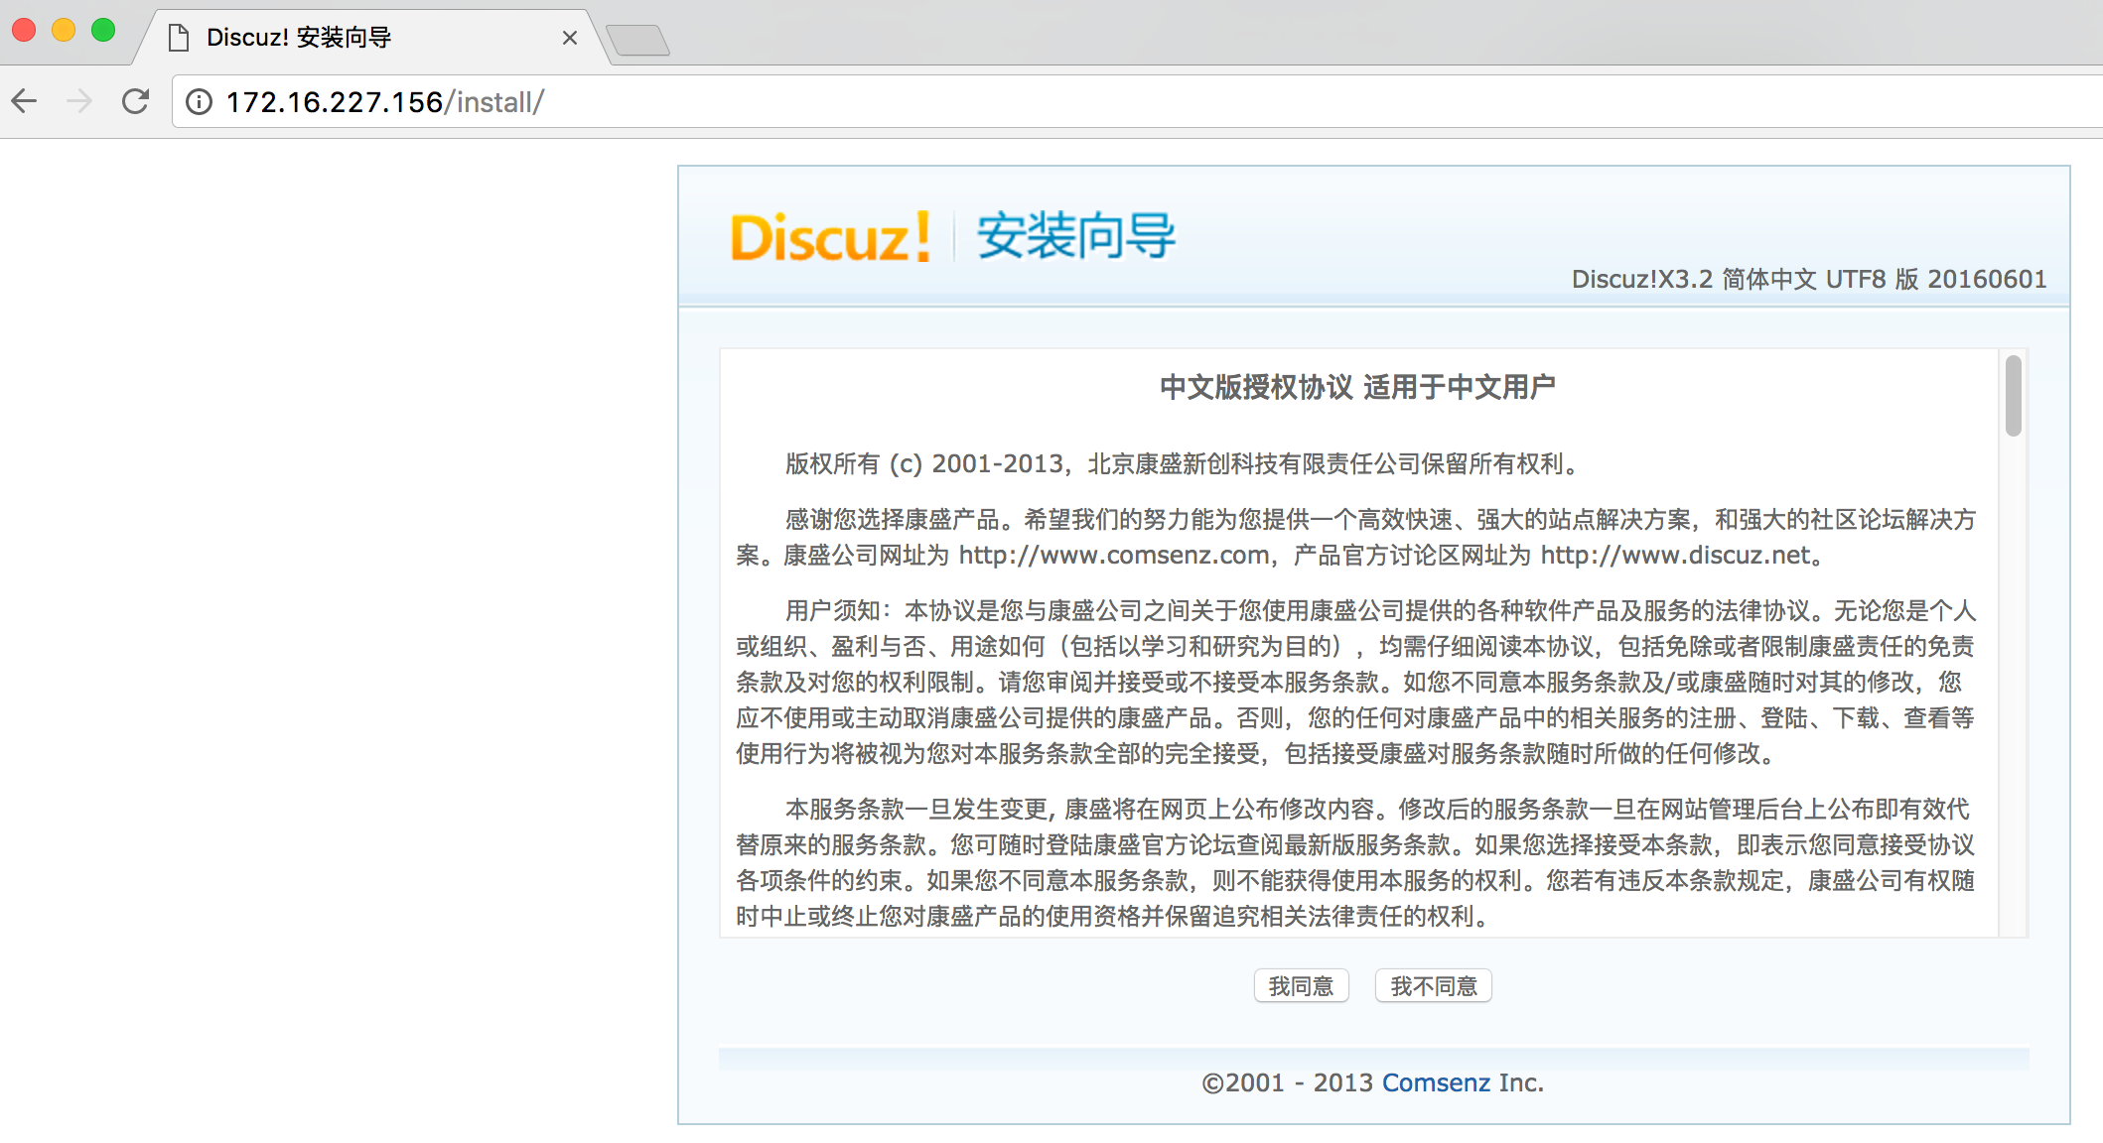

10、安装Discuz

详细安装步骤 略

要注意添数据库的地方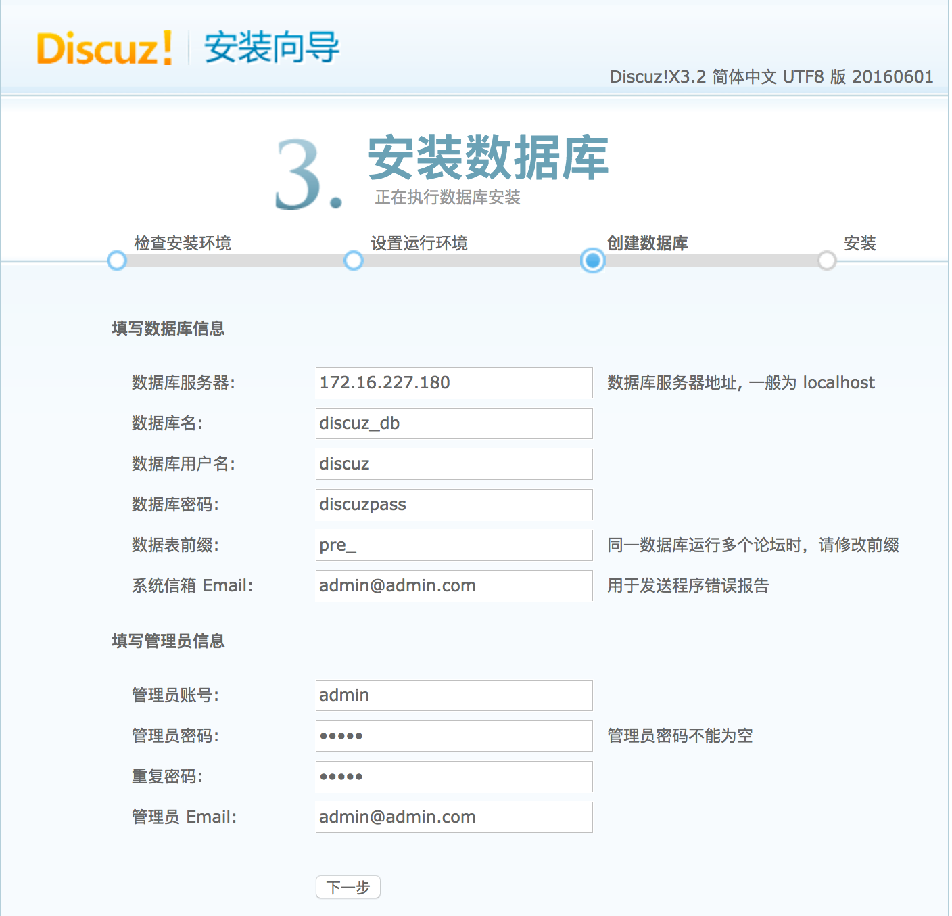

11、更改Client端DNS，进行测试

